December 9th, 2007
Hi
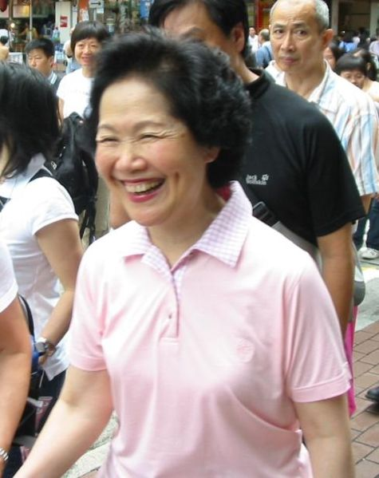
As mentioned last week, a Legco by-election was held. Anson Chan (photo) easily won easily, obtaining about 55% of the vote to about 43% by Regina Yip, the pro-Government candidate. But she certainly got a lot of criticism on her first day in Legco last Wednesday. She was savagely attacked by a government minister/bureau chief for her work in colonial times and, among other things for being a ‘sudden democrat’. Interestingly, during the 1967 HK riots, when the Cultural Revolution spilt over from China to HK, this same minister had been jailed by the British for his involvement.

Gradually breaking ties with our days at the Chinese University. Remember that I had a detergent bottle with a little detergent left over from when at CU? Well, I threw away the bottle the other day. It had been empty for some time and was just sitting on the side of the sink. I do not use much dishwashing detergent as the detergent is similar in chemical structure to a female hormone and (too much) of it can have harmful effects on the body!!
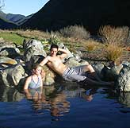
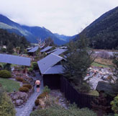
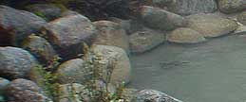
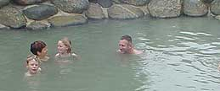
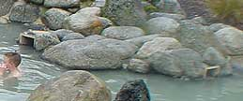
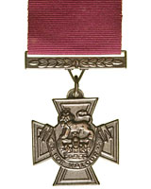
A couple of interesting TV items about New Zealand. First, someone broke into a war museum and stole many war medals among them nine VCs (including the almost unique medal and bar (ie a second one) awarded to Charles Upham – remember Gavin, he also attended Christ’s College)! This caused a lot of revulsion around the country, including me too. As the medals are easily recognised and the thief would be unable to sell them, it is suspected that they were stolen for some collector. The other item, which Leonie will be interested in, was documentary, which dealt with the West Coast of the South Island. It included the Maruia hot springs near Lewis Pass, where we camped with Uncle Keith and the ‘boys’ when you were in NZ. Remember? However, the documentary dealt with the upscale side of the area (accommodation and restaurant) and not the camping ground nor BBQ dinners (which we had)! Anyway, they showed the hot pools that we used. The place is owned (?operated) by a Japanese man, who has lived there for 16 years, which probably explains why we were wondering why the buildings and pools there have so much Japanese influence.

The other day, I received an e-mail with wedding photos from the photographer. I have not looked at all of them yet as there are more than 1000!
After saying in the last letter, that I would takes my runs a bit easier, It did not quite turn out that way for yesterday’s run. At 2 hr 6 min, the time was just one minute slower than the best for that route!


Yesterday, tickets for next year’s Rugby 7s tickets went on sale. They were sold out quickly; the queue began about 24 hrs prior to sale but only about 2500 people were successful. Only 5000 tickets for the public! Last year, according to one unsuccessful disgruntled fan who was interviewed on the radio, 10 000 were allocated for the public. New Zealand won the second round of the international Rugby 7s tournament, held in South Africa, thrashing Fiji in the final. So, they have now won the two opening rounds.
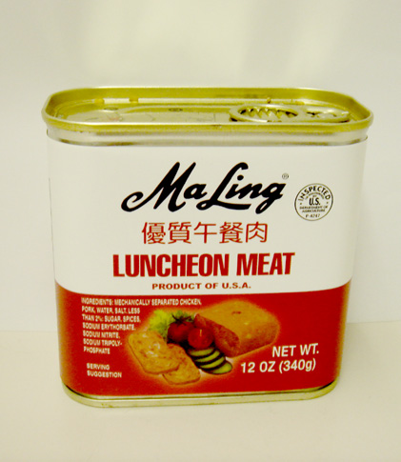
More food from China has been found to be contaminated. However, this time, it is not just any producer but the ‘Ma Ling’ company, one of the biggest canned food companies in China. Their canned meat contained antibiotics and a preservative, known to be carcinogenic. The company itself did not help things by denying there were any such substances in their food and saying they would continue productions as usual! The largest HK supermarkets have taken their products of the shelves while further tests are being done.
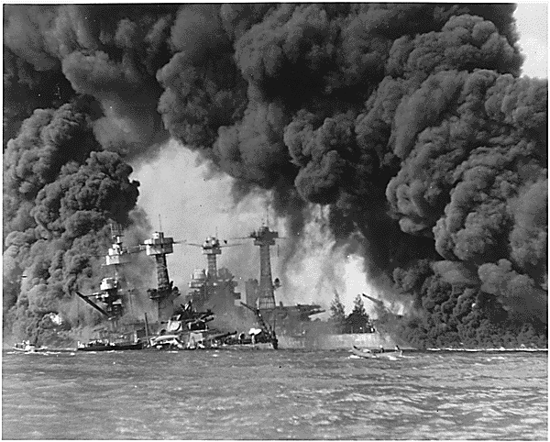
Thursday (in HK) was the 66th anniversary of the attack on Pearl Harbor (Dec 7th in Honolulu).
That’s about it for now.

Cheers

